TITLE: Tristen Erpelding, CSCI 200 A, School Local Portal (SLP)
PROBLEM DESCRIPTION: My project is a comprehensive school management system. It enables school administrators to efficiently manage various aspects of their institution, such as student enrollment, attendance, grading, scheduling, and financial management. The system provides a user-friendly CLI (command-line) interface that enables easy navigation and interaction. Additionally, students will be able to sign in with their accounts and view their profiles, including attendance records, grades, and other relevant information. The program uses various data structures and algorithms to optimize its performance, and it also generates analytical reports to help administrators evaluate student and teacher performance. The ultimate goal of this project is to create an efficient and reliable tool that simplifies the day-to-day tasks of school administration, making it easier to provide quality education to students.
DATA DESCRIPTION: In my school management system project, I will incorporate vectors to store various sets of data, such as student and teacher information, attendance records, and grading data. Vectors are an ideal choice for this project, as they offer dynamic sizing, easy manipulation, and quick access to data elements. To store the data, I will use a plain text file format, which is simple and easily accessible. The data will be organized into fields and records, with each record representing an individual student, teacher, or class. I will use C++'s file I/O capabilities to read and write data to the file, and I will implement appropriate error checking and validation to ensure data integrity. If there is time at the end of the project, I will also implement security and encryption measures to protect sensitive data.
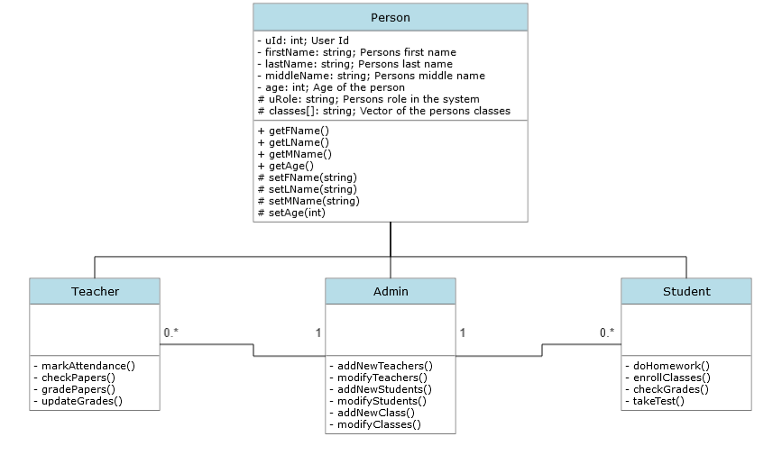

PROCEDURAL DESCRIPTION:
// Create Person Class
// Have a bunch of things defined which can be seen the UML,
// Create 3 separate classes derived from the Person Class
// Have a bunch of class specific functions defined
// Student has vector of different Classes class objects
// Create Classes Class
// Class specifics like capacity, name, etc.
// Main Program
// Prompt for login
// Dependent on login have different options available
// Student Login
// Allow to view student profile
// Allow to view grades
// Allow to view class schedule
// Teacher Login
// Allow to create homework
// Allow to create test
// Allow to grade assignments
// Allow to view all grades
// Allow to update grades
// Admin Login
// Allow to edit classes
// Allow to edit students
// Allow to edit teachers
// End Main Program

CONCERNS: I currently do not have many questions, the only thing that I may need help on will be creating the managing system and how Admins can edit the Teacher and Student information but not vice versa. Another question I may have is how to check the status of a user account and see if it is a admin, teacher, or student.

